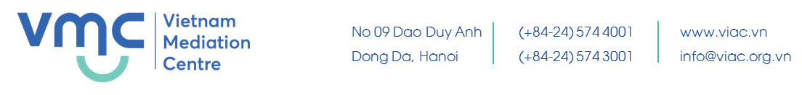
CURRICULUMN VITAE

CHU TIEN DZUNG |  |  |  | 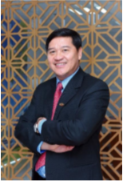
President of HCMC Business Association
General Director of Saigon Industry Corporation - Limited Company
 | 58 – 60 Nguyen Tat Thanh, Ward 12, District 4, HCMC
 | 090 393 5678 |  | 028. 38. 255. 999
 | dungct@cns.com.vn
 | IT, Law
 | English, Vietnamese
Education
1978 - 1982 |  | Bachelor of Physics, Hanoi National University of Education 2
1990 - 1992 |  | Bachelor of Economics, Ho Chi Minh City University of Economics
1997 - 1999 |  | Bachelor of Informatics, Hanoi University of Science
2001 - 2004 |  | Master of Business Administration, Ho Chi Minh City University of Economics
Work history
10/1982 - 1996 |  | - Working at Irrigation Construction United Enterprise 4 - Dau Tieng Enterprise;  - Leader of Computing Team of Construction Contractors 4;  - In charge of Computing Construction Corporation 4;  - Party Secretary of Construction Corporation 4, Party member of Construction Corporation 4 terms (1989-1994), term (1995-2000);  - Deputy Head of Construction Corporation 4
07/1996 - 12/1998 |  | Deputy Director of Thanh Doan Science and Technology Development Young Center  Principal of Thanh Doan Computer School
1999 - 07/2000 |  | Principal of Thanh Doan Technical School of Foreign Language and Information Technology
08/2000 - 10/2010 |  | Director of Quang Trung Software Development Company
10/2010 – 7/2014 |  | Chairman of the Board of Members of Quang Trung Software Development Company Ltd.
2008 – 2017 |  | President of Ho Chi Minh City IT Association
2008 – 2018 |  | - Vice President of Vietnam Software Association  - Vice Chairman of IT Development Policy Council.  - Vice President of Vietnam Software Association and IT Services (VINASA)
2014 - present |  | General Director of Saigon Industry Corporation - Limited Company
10/2016 - present |  | President of HCMC Business Association
Awards
- 2nd Labor Medal in 2016, 3rd Labor Medal in 2011
- Merit from the Prime Minister, Ministry of Planning and Investment, Ministry of Industry and Trade, Ministry of Information and Communications, VCCI, HCMC People's Committee ...
- Certification of typical national entrepreneur and awarding of Thanh Giong Cup in 2016
- "Typical Ho Chi Minh City Entrepreneur" in 2016.

